**Project Proposal**

**Academic Year 2018**

**Candidate Details**

Index No: 1615173

Name of the Candidate: Vithusha Uthayakumar

Address: 21 B Inner Vandervert Place, Dehiwala

Contact Telephone Numbers: 076 980 9592

Email: [vithushauthay@gmail.com](mailto:vithushauthay@gmail.com)

Supervisor/Advisor Details

|  |  |  |
| --- | --- | --- |
|  | Supervisor 1(IT related) | Supervisor 2 (Optional) |
| Name | Mr. S. Suseendran |  |
| Designation | BIT Degree division |  |
| Workplace address | ESOFT Computer Studies  (PVT) Ltd. 235, Galle Road,  Colombo - 04. |  |
| Academic/  professional/  qualifications and memberships | MScIT, BSc, DCSD,  DPM(UK) |  |
| Work Experience | 7+ years in teaching, 4+ years in management |  |
| Email: | [sivasusee@gmail.com](mailto:sivasusee@gmail.com) |  |
| Phone number/s: | 077 300 2209 |  |

**Project Details**

**Title of the Project**:

Web Based Pharmaceutical Distribution System for Sunwaay Lanka Lab.

**Name and address of Client**:

Sunwaay Lanka Lab.

No 65, Kadawatha road,

Kalubowila.

**Motivation for project:**

Sunwaay Lanka Lab is one of the most famous Pharmaceutical Distributors in Sri Lanka. Started in 2014 and their main goal is to distribute pharmaceutical devices to pharmacies all over the island. Now they use manual file system for current business transactions. Every day they do transactions with their suppliers and customers. Those transactions are written in bill books. Manual invoices are given to the customers. And Good Receiving Notes are note down in the books. So they face following problems.

• It is difficult to manage daily business transactions in manually. Have to write all the transactions.

• It is difficult to find details, selling prices, cost prices of products and also details of customers, suppliers.

• Facing problems in finding payment details of customers’ and suppliers’ quickly.

• There are several difficulties in managing stock balance details and customers have no idea about stock balance.

• Decision making process is difficult as there is no a systematic way to generate report.

In order to overcome these problems they want to change their manual system into a web based computerized Information System.

This project will give me the opportunity to practice what I have learnt in BIT degree and well give a valuable experience which will be useful towards employment.

**Objectives and scope of proposed project:**

Objectives of the system are to help to generate reports when needed. So the decision making process can be easily done. Minimize the time spend in manual transactions. Easy to find cost price, selling price and details of a products. Helps to track the payments details and keep up-to-date. Makes availability and avoid redundancy. Login and authentication helps to secure the database of the system form outsiders.

The system does not deal with distribution of drugs only pharmaceutical devices.

In this system, it has been divided in to the following modules.

* Staff(Internal users) Management
* Insert new staff details, helps to track the activities of users and grand privileges to them.
* Supplier Management
* Insert new suppliers.
* Product Management
* Having information and details about products.
* Purchase Order Management
* Ordering to suppliers to purchase.
* Stock Receiving Management
* Receiving stocks/products from suppliers.
* Payment Management for suppliers
* Maintaining a payment management to know about settled payments and due payments.
* Customer Management
* Having details about customers.
* Customer Order Management
* Controlling the Orders getting from customers.
* Sales Management
* Controlling the sales of the company.
* Invoice Management
* Billing invoices to the customers’ orders and also store payment details of customers, delivery status.
* Stock Management
* Maintain a real-time stock balance.
* Report Management
* Backup Management

**Critical Functionalities for Project:**

* Purchase order, stock receiving, payment, customer order and invoice managements.
* Find a particular cost/sell price of a product to a particular supplier/customer.
* Maintaining the proper stock control. (Showing real time stock balance for customers when the order online)
* Maintain the payment details and able to check the due payments.

**Itemized list of deliverables of the system:**

* Fully completed web based pharmaceutical distribution system.
* User manual and System manual.
* Training.
* Implementation support.

**A project plan using Gantt chart (include the work involved in system development as well as writing the dissertation):**

**Work involved in system development:**

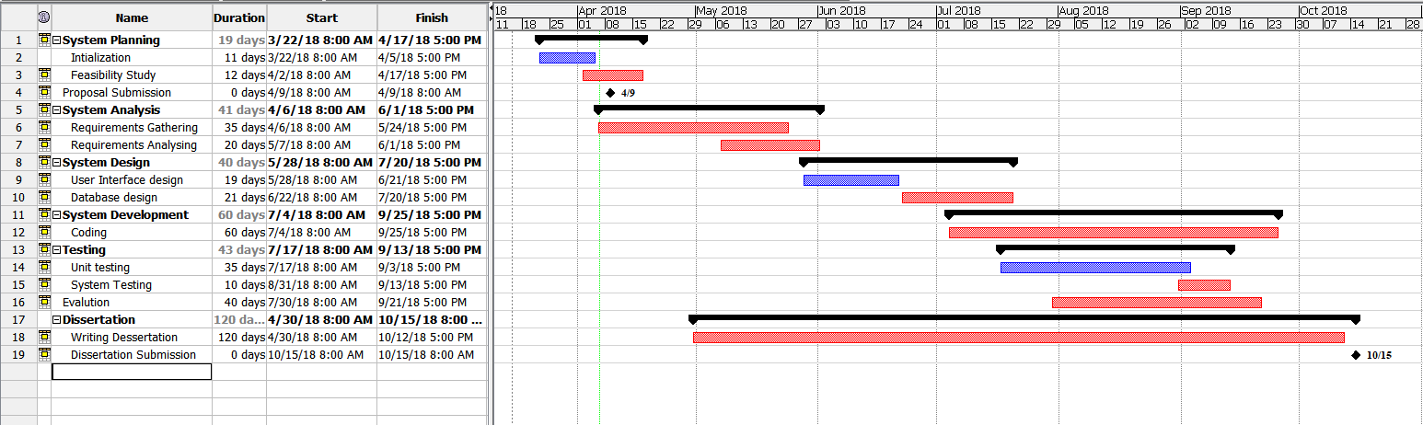

**Work involved in writing dissertation:**

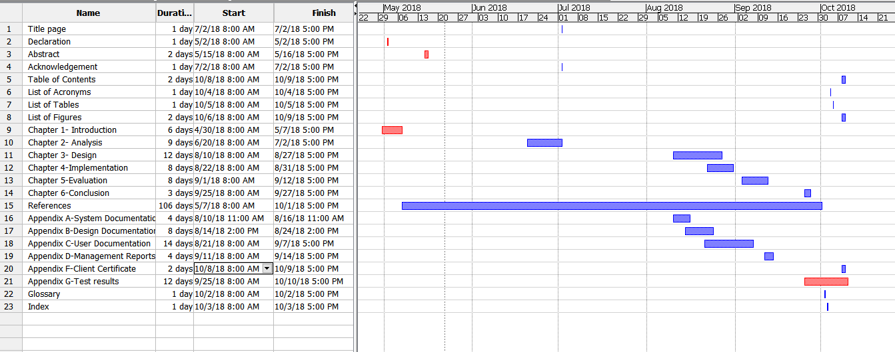

**Resource requirements for project (e.g., hardware, software...):**

|  |  |
| --- | --- |
| **Hardware** | **Software** |
| Intel Core i3  Processor  4GB RAM  1TB  & Cloud server | Windows 10  Software Bundle: XAMPP   * Web server- Apache * Web script- PHP 7 * DBMS- MySQL * IDE- NetBeans 8.2   Other technologies   * HTML 5/CSS, CSS 3 * Bootstrap 3.3.7 |

**Proposed way of self-evaluating the success of your system:**

* Meet the supervisor regularly and the get the feedback.
* Meet the client and confirm whether the system meets its requirements.
* System will be fully tested using a test plan, test cases.
* Actual data will be loaded and a full testing will be done.
* User acceptance testing.